Day 8
LINKEDLIST:
CODE:
class Node {
int data;
Node next;

Node(int data) {
this.data = data;
this.next = null;
}
}
public class LinkedList {
static Node head = null;
// Insert at Beginning
static void insertFirst(int data) {
Node newNode = new Node(data);
newNode.next = head;
head = newNode;
}
// Insert at End
static void insertLast(int data) {
Node newNode = new Node(data);
if (head == null) {
head = newNode;
return;
}
Node temp = head;
while (temp.next != null) {
temp = temp.next;
}
temp.next = newNode;
}
// Insert at Position (1-based)
static void insertPosition(int pos, int data) {
if (pos <= 0) {
System.out.println("Invalid Position");
return;
}
if (pos == 1) {
insertFirst(data);
return;
}
Node newNode = new Node(data);
Node temp = head;
for (int i = 1; i < pos - 1; i++) {
if (temp == null) {
System.out.println("Invalid Position");
return;
}
temp = temp.next;
}
if (temp == null) {
System.out.println("Invalid Position");
return;
}
newNode.next = temp.next;
temp.next = newNode;
}
// Delete First
static void deleteFirst() {
if (head == null) {
System.out.println("List is Empty");
return;
}
head = head.next;
}
// Delete Last
static void deleteLast() {
if (head == null) {
System.out.println("List is Empty");
return;
}
if (head.next == null) {
head = null;
return;
}
Node temp = head;
while (temp.next.next != null) {
temp = temp.next;
}
temp.next = null;
}
// Delete at Position (1-based)
static void deletePosition(int pos) {
if (head == null) {
System.out.println("List is Empty");
return;
}
if (pos <= 0) {
System.out.println("Invalid Position");
return;
}
if (pos == 1) {
head = head.next;
return;
}
Node temp = head;
for (int i = 1; i < pos - 1; i++) {
if (temp == null) {
System.out.println("Invalid Position");
return;
}
temp = temp.next;
}
if (temp == null || temp.next == null) {
System.out.println("Invalid Position");
return;
}
temp.next = temp.next.next;
}
// Display
static void display() {
if (head == null) {
System.out.println("List is Empty");
return;
}
Node temp = head;
while (temp != null) {
System.out.print(temp.data + " -> ");
temp = temp.next;
}
System.out.println("null");
}
public static void main(String[] args) {
System.out.println("Insert Operations");
insertFirst(20);
insertFirst(10);
insertLast(30);
insertPosition(3, 25);
display();
System.out.println("\nDelete First");
deleteFirst();
display();
System.out.println("\nDelete Last");
deleteLast();
display();
System.out.println("\nDelete Position");
deletePosition(2);
display();
}
}
OUTPUT:
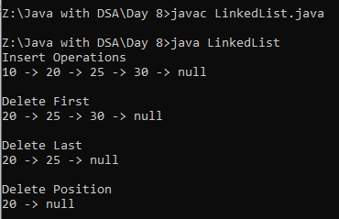
STACK OPERATION:
CODE:
import java.util.*;
class Main{
public static void main(String[] args){
Stack<Integer> s=new Stack<>();
s.push(5);
s.push(12);
s.push(19);
s.push(21);
s.push(23);
System.out.println("Inserion:"+s);
s.pop();
System.out.println("Poped:"+s);
System.out.println("Peek Element:"+s.peek());
System.out.println("size of the stack:"+s.size());
System.out.println("Is Empty?:"+s.isEmpty());
}
}
OUTPUT:
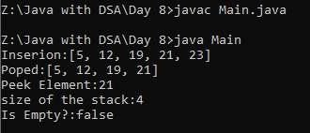
VALID PARENTHESIS:
CODE:
import java.util.*;
class parenthesis{
public static void main(String[] args){
Scanner sc=new Scanner(System.in);
Stack<Character> s=new Stack<>();
String str=sc.nextLine();
for(int i=0;i<str.length();i++){
char ch=str.charAt(i);
if(ch=='(' || ch=='[' || ch=='{'){
s.push(ch);
}
else{
if(s.peek()=='(' && ch==')'){
s.pop();
}
else if(s.peek()=='[' && ch==']'){
s.pop();
}
else if(s.peek()=='{' && ch=='}'){
s.pop();
}
else if(s.isEmpty()){
System.out.print("False");
return;
}
}
}
if(!s.isEmpty()){
System.out.println("False");
}
else{
System.out.println("True");
}
}
}
OUTPUT:
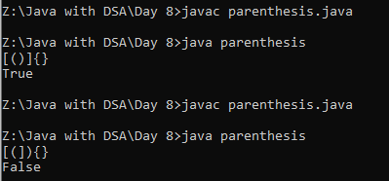

STRING REMOVE THE DIGIT:
CODE:
import java.util.*;
class digit{
public static void main(String[] args){
Stack<Character> s=new Stack<>();
String str="he34ll6o";
for(int i=0;i<str.length();i++){
char ch=str.charAt(i);
if(Character.isLetter(ch)){
s.push(ch);
}
}
for(Character ch:s){
System.out.print(ch);
}
}
}

OUTPUT:
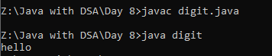

STRING PUSH AND POP:
CODE:
import java.util.*;
class once{
public static void main(String[] args){
Scanner sc=new Scanner(System.in);
Stack<Character> s=new Stack<>();
String str=sc.nextLine();
for(int i=0;i<str.length();i++){
char ch=str.charAt(i);
if(!s.isEmpty() && s.peek()==ch){
s.pop();
}
else{
s.push(ch);
}
}
for(Character ch:s){
System.out.print(ch);
}
}
}

OUTPUT:
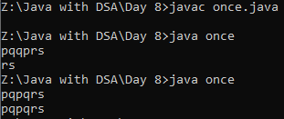
STRING PALINDROME USING STACK:
CODE:
import java.util.*;
class pali{
public static void main(String[] args){
Scanner sc=new Scanner(System.in);
Stack<Character> s=new Stack<>();
String str=sc.nextLine();
for(int i=0;i<str.length();i++){
s.push(str.charAt(i));
}
boolean pali=true;
for(int i=0;i<str.length();i++){
if(str.charAt(i)!=s.pop()){
pali=false;
break;
}
}
if(pali){
System.out.println("palindrome");
}
else{
System.out.println("Not a Palindrome");
}
}
}
OUTPUT:
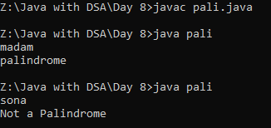
POSTFIX:
CODE:
import java.util.*;
class post{
public static void main(String[] args){
Scanner sc=new Scanner(System.in);
Stack<Integer> s=new Stack<>();
String str=sc.nextLine();
for(int i=0;i<str.length();i++){
char ch=str.charAt(i);
if(Character.isDigit(ch)){
s.push(ch-'0');
}
else{
int a=s.pop();
int b=s.pop();
if(ch=='+'){
s.push(b+a);
}
else if(ch=='-'){
s.push(b-a);
}
else if(ch=='*'){
s.push(b*a);
}
else if(ch=='/'){
s.push(b/a);
}
}
}
System.out.print(s);
}
}
OUTPUT:
